Semester Two

Examination 2024

Question/Answer booklet

BIOLOGY
UNITS 3 & 4

Name: _______________________________________________________

Teacher: ___________________________________________________

TIME ALLOWED FOR THIS PAPER

Reading time before commencing work: Ten minutes
Working time for the paper: Three hours

MATERIALS REQUIRED/RECOMMENDED FOR THIS PAPER

To be provided by the supervisor:
- This Question/Answer Booklet.

To be provided by the candidate:
- Standard items: Pens, pencils, eraser or correction fluid, ruler, highlighter.

- Special items: Calculators satisfying the conditions set by the SCSA for this subject.

IMPORTANT NOTE TO CANDIDATES
No other items may be taken into the examination room. It is your responsibility to ensure that you do not have any unauthorised notes or other items of a non-personal nature in the examination room. If you have any unauthorised material with you, hand it to the supervisor before reading any further
Structure of this paper

Section | Number of questions available | Number of questions to be answered | Suggested working time  (minutes) | Marks available | Percentage of exam
Section One:  Multiple-choice | 30 | 30 | 40 | 30 | 30
Section Two:  Short answer | 5 | 5 | 90 | 100 | 50
Section Three  Extended answer | 2 | 1 | 50 | 20 | 10
 | 2 | 1 |  | 20 | 10
 |  |  |  | Total | 100
Instructions to candidates

- The rules for the conduct of the Western Australian external examinations are detailed in the Year 12 Information Handbook 2024: Part II Examinations. Sitting this examination implies that you agree to abide by these rules.

- Write your answers in this Question/Answer booklet preferably using a blue/black pen. Do not use erasable or gel pens.

- Answer the questions according to the following instructions.

Section One: Answer all questions on the separate Multiple-choice answer sheet provided. For each question, shade the box to indicate your answer. Use only a blue or black pen to shade the boxes. Do not use erasable or gel pens. If you make a mistake, place a cross through that square, then shade your new answer. Do not erase or use correction fluid/tape. Marks will not be deducted for incorrect answers. No marks will be given if more than one answer is completed for any question.

Section Two: Write your answers in this Question/Answer booklet. Wherever possible, confine your answers to the line spaces provided.

Section Three: Consists of two parts each with two questions. You must answer one question from each part. Tick the box next to the question you are answering. Write your answers in this Question/Answer booklet.

- You must be careful to confine your answers to the specific questions asked and to follow any instructions that are specific to a particular question.

- Supplementary pages for planning/continuing your answers to questions are provided at the end of this Question/Answer booklet. If you use these pages to continue an answer, indicate at the original answer where the answer is continued, i.e. give the page number.

Section One: Multiple-choice 30% (30 marks)
This section has 30 questions. Answer all questions on the separate Multiple-choice answer sheet provided. For each question, shade the box to indicate your answer. Use only a blue or black pen to shade the boxes. Do not use erasable or gel pens. If you make a mistake, place a cross through that square, then shade your new answer. Do not erase or use correction fluid/tape. Marks will not be deducted for incorrect answers. No marks will be given if more than one answer is completed for any question.
Suggested working time: 40 minutes.
___________________________________________________________________

1. The process by which large amounts of biological data can be analysed via computational and mathematical modelling is known as

- Bioinformatics.
- Genome sequencing.
- Comparative biochemistry.
- Biodiversity.

- The most likely reason that Australian biosecurity agencies deploy insect traps around major air and sea ports that allow entry into Australia is to

- capture mosquitoes to stop spread of Ross River virus.
- contribute to the entry of disease-causing insects.
- capture exotic or non-native insects.
- contain bees that may swarm and sting people.

- A blue tongue lizard lying flat on a hot rock will be gaining heat via

- convection from the hot rock and conduction from the sun.
- radiation from the sun and conduction from the rock.
- conduction from the rock and convection from the sun.
- radiation from the sun and convection from the rock.

- When a DNA molecule is exposed to a mutagen, the following events occur

- Mutation
- Change in protein structure
- Change in polypeptide sequence
- Change in cell activity

Which of the following represents the correct order in which these events occur?

- (i), (ii), (iii), (iv)
- (i), (ii), (iv), (iii)
- (i), (iii), (ii), (iv)
- (iv), (i), (iii), (ii)
Since the 1990’s many of Australia’s cotton growers have begun creating transgenic cotton by inserting genes from a soil bacterium into the cotton plant which then produces toxic proteins that kill the bollworm that likes to feed on the cotton.

5. Which of the following would be a positive outcome resulting from this genetic modification?

- Increasing the reproductive rate of the bollworm.
- Increasing the need to use insecticides.
- Decreasing yield of cotton.
- Decreasing the need to use insecticides.

6. Which of the following correctly lists features of viruses?

- Cell walls, circular chromosomes, reproduce independently.
- Reproduce inside host cells, cell walls, DNA or RNA strand.
- DNA or RNA strand, reproduce inside host cells, no cell wall.
- No cell wall, reproduce independently, DNA or RNA strand.

7. Which of the following statements about DNA best describes the way in which genetic information is stored?

- A molecule of DNA contains thousands of repeated units which are paired randomly opposite each other.
- Nitrogenous bases in DNA occur in complementary pairs on opposite strands.
- There are four different bases in DNA which give rise to sixty-four different possible DNA codons.
- There are only a few possible combinations and sequences of bases along a DNA strand.

8. The internal environment of a freshwater fish is hypertonic to the surrounding water.
This means that their internal solute concentration

- is less than that of their surroundings.
- changes as the surrounds fluctuate.
- is more than that of their surroundings.
- Is the same as that of their surroundings.

9. Which of the following characteristics would you not expect to find in a halophyte?

- Abundant stomata.
- Salt bladders
- Small leaves.
- Succulent leaves.

10. Ross River disease is caused by a mosquito vector and is common in hot humid areas in Australia. One method that would be most effective in reducing the spread of this disease is

- keeping doors and windows open to allow cool air to enter houses.
- removing stagnant water bodies from around houses.
- using insect nets during the day.
- covering all rivers and lakes with nets.

11. Which of the following would be least effective in causing reproductive isolation between populations of the same species? The populations

- are a different in size.
- have different breeding seasons.
- have different mating rituals.
- produce gametes that do not survive.

12. Nile crocodiles can be found living on the southern edge of the Sahara
desert in Africa. Their habitat is extremely dry, there may be no water available for 6
to 8 months of the year and there are only short periods of food supply for these
reptiles. They tend to live underground in caves or burrows during the extended
dry periods.

Why is it more difficult for a mammal than a reptile to spend 6 to 8 months each year in a burrow?

- Mammals are more active than reptiles.
- Reptiles excrete urea rather than uric acid.
- Mammals must feed more often than reptiles.
- Reptiles are endothermic while mammals are ectothermic.

13. Which of the following statements about evidence for evolution is correct?

- Insect wings and bird wings are homologous.
- Amino acid sequences are identical in all vertebrate species.
- Vertebrate species embryo’s share common features during development.
- Fossils formed from soft bodied organisms can be absolutely dated.

Questions 14 and 15 refer to the following information.

A student took twenty identical hairy leafed plants, shaved the hairs off ten of the plants leaves and placed both plants into a glass enclosure. The plants were exposed to the same conditions: constant humidity and temperature, no water, and were exposed to light continuously for two days. All plants were weighed before the experiment began and again after two days and an average was calculated.

 | Average initial weight (g) | Average final weight (g)
Plants 1-10 (no hairs) | 218.9 | 200.3
Plants 11-20 (with hairs) | 214.7 | 200.9

14. The independent variable in the experiment above is

- weight of the plants.
- absence of hairs on leaves
- water content of leaves.
- exposure to light.

15. The control group for the above experiment is

- plants with unshaved leaves.
- plants with shaved leaves.
- plants continuously exposed to light.
- final weight of plants.

16. Antibiotics are not used to treat viral infections. This is because

- viruses can mutate quickly and become resistant.
- viruses can only be controlled by using vaccinations.
- viruses do not have cellular structures that can be affected by antibiotics.
- viruses do not contain any genetic material.

17. The following table shows the volume of water gained and lost by an animal living in a hot environment.

Water gain (cm³) |  |  | Water loss (cm³)
Food | Drink | Metabolism | Urine | Faeces | Evaporation | Breathing
1300 | 1360 | 320 | 740 | 160 | 1260 | 540

The percentage loss of water from the animal during the day is

- 99.6%
- 91.9%
- 89.6%
- 90.6%

18. Some cattle are hornless while others are horned. These traits are determined by a single pair of alleles. The allele for the hornless trait (H) is dominant to the allele for the horned trait (h). Hornless cattle and horned cattle were mated and the number of offspring with horns or without horns are shown below.

Number of hornless offspring | Number of horned offspring
20 | 19

What are the genotypes of the hornless parent and the hornless offspring?

 | Parent genotype | Offspring genotype
(a) | HH | Hh
(b) | Hh | HH
(c) | Hh | Hh
(d) | HH | HH

19. The tuberculosis pathogen is transmitted to a new host via

- ingestion of water.
- inhalation of droplets.
- skin to skin contact.
- vectors.

Question 20 refers to the diagram below.

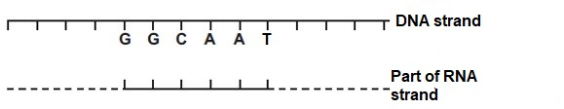

20. The correct order of complementary bases in the RNA strand are

- C, C, G, T, T, A.
- G, G, C, A, A, T.
- C, C, G, U, U, A.
- U, U, G, T, T, A.

21. Cells that are undergoing mitosis can be fixed and then stained so that their chromosomes can be viewed with the aid of a microscope. Which of the following correctly identifies how you could distinguish between a cell in metaphase and a cell in anaphase?

 |  | Metaphase | Anaphase
 | (a) | DNA coils into chromosomes | Nuclear membrane disappears and spindle fibres form
 | (b) | Chromosomes arranged along equator of cell | Chromosomes pulled apart by spindle fibres and chromatids are separated
 | (c) | Nuclear membrane disappears and spindle fibres form | DNA coils into chromosomes
 | (d) | Chromosomes pulled apart by spindle fibres and chromatids are separated | Chromosomes arranged along equator of cell
.

22. The sugar glider and the flying squirrel have a similar appearance. Both have a flap of skin between the forelimbs and hind limbs that enable them to glide from tree to tree or branch to branch. A flying squirrel can be found in the Northern hemisphere while the sugar glider is found within Australia only.

The process that has led to both these animals having similar features even though they live far away from each other is known as

- macroevolution.
- divergent evolution.
- microevolution.
- convergent evolution.

- Which of the following is correct when comparing marine and freshwater fish?

 | Freshwater fish | Marine fish
(a) | Produce large quantities of urine | Produce small quantities of urine
(b) | Produce concentrated urine | Produce dilute urine
(c) | Gain water across gills | Gains salt/ ions across gills
(d) | Actively drink water | Do not drink any water

24. Which of the following correctly lists the factors required for diseases to spread?

(a) herd immunity, virulence of pathogen, growth of pathogen.
(b) susceptible hosts in high density, growth of pathogen, transmission.
(c) growth of virulent pathogen, transmission, herd immunity.
(d) susceptible hosts in high density numbers, persistence in a reservoir, vaccinations.

- Malaria is caused by unicellular protists. Immature forms of Plasmodium falciparum that are injected into a host via mosquito saliva are known as

- merozoites.
- gametophytes.
- sporozoites.
- zygotes.

26. Which of the following correctly matches the infectious diseases with the type of pathogen that causes the disease?

 | Bacterial | Viral | Fungal
(a) | Crown gall | Tuberculosis | Chytridiomycosis
(b) | Tuberculosis | Crown gall | Influenza
(c) | Phytophthora dieback | Ross river disease | Chytridiomycosis
(d) | Tuberculosis | Influenza | Chytridiomycosis

27. Quarantine can be defined as

- a period of isolation undertaken by potentially infected individuals.
- monitoring of any vectors entering a community.
- prohibiting the entry of items carrying infectious diseases into a country.
- preventing the replication of new pathogens from old ones.

Question 28 relates to the diagram shown below.
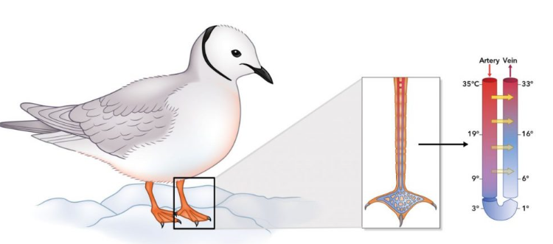

28. The adaptation shown above is known as

- vasoconstriction of surface blood vessels.
- counter-current heat exchange.
- aestivation from cold conditions.
- piloerection of hairs.

29. Which of the following statements about why an understanding of population dynamics is important when considering a captive breeding programme are correct?

- it allows for the identification of trends in population numbers
- it allows for correction of factors that are causing a decline in births
- it determines the way in which organisms’ mate and rear offspring
- it will determine the type of enclosure and food the organism will need to survive

(a) (i), (ii) and (iv) only
(b) (ii) and (iii) only
(c) (i) and (ii) only
(d) (i), (iii) and (iv) only

Question 30 refers to the information shown below.

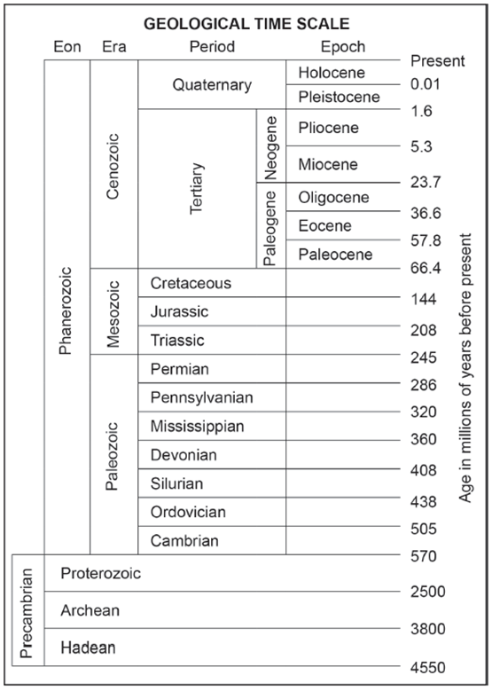

30. During which geological time era would a fossil specimen dated at 900 000 years old have been alive?

(a) Pliocene.
(b) Cenozoic.
(c) Quaternary.
(d) Pleistocene.

End of Section One

Section Two: Short answer (100 marks)
This section has five questions. Answer all questions. Write your answers in the spaces
provided.

Supplementary pages for planning/continuing your answers to questions are provided at the end of this Question/Answer booklet. If you use these pages to continue an answer, indicate at the original answer where the answer is continued, i.e. give the page number.

Suggested working time: 90 minutes.
_________________________________________________________________________

Question 31 (20 marks)

Muscular dystrophy is a condition which often affects golden retriever dogs. It is caused by a mutation of a gene which codes for the protein dystrophin, which gives structural stability to all membranes within muscle cells. Abnormal dystrophin allows movement of substances in and out of a cell that would not normally be moved.

- (i) Define the term mutation. (1 mark)
_________________________________________________________________
_________________________________________________________________

(ii) Explain why a mutation involving an intron would affect translation but mutations within exons could. (4 marks)
_________________________________________________________________
_________________________________________________________________
_________________________________________________________________
_________________________________________________________________
_________________________________________________________________
_________________________________________________________________
_________________________________________________________________
_________________________________________________________________

The following pedigree shows the inheritance of muscular dystrophy within one golden retriever family.

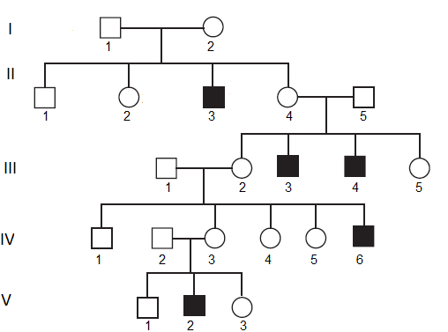

- Explain, using evidence from the pedigree, the mode of inheritance of muscular dystrophy. (5 marks)
______________________________________________________________________
______________________________________________________________________
______________________________________________________________________
______________________________________________________________________
______________________________________________________________________
______________________________________________________________________
______________________________________________________________________
______________________________________________________________________
______________________________________________________________________
______________________________________________________________________

- Using D and d to represent alleles, state the genotypes that would be possible for individuals: (2 marks)

- II2 _________________________________________
(ii) V1 _________________________________________

Elimination of non-desirable traits in many animals and plants, is difficult but improvements to the overall genetic pool can be made by breeding animals at the more desirable end of the continuum. Artificial or selective breeding has been used by humans for thousands of years but these days often the process can be achieved via biotechnological means.

- (i) State a key difference between producing organisms via biotechnology as
opposed to artificial selection. (2 marks)
______________________________________________________________________
______________________________________________________________________
______________________________________________________________________

(ii) Outline one advantage and one disadvantage to using artificial selection rather than biotechnological techniques to produce animals with advantageous characteristics. (2 marks)
______________________________________________________________________
______________________________________________________________________
______________________________________________________________________

A microbe used in the creation of transgenic organisms is the Agrobacterium tumefaciens.
(e) (i) State the role that this bacterium plays in this process. (1 mark)
_____________________________________________________________________
(ii) Outline why Agrobacterium is so well suited to this role. (3 marks)
_____________________________________________________________________
______________________________________________________________________
______________________________________________________________________
______________________________________________________________________
Question 32 (24 marks)
- Distinguish between the following terms: (4 marks)

- Infectious and non-infectious.
______________________________________________________________________
______________________________________________________________________
______________________________________________________________________
______________________________________________________________________

- Reservoir and vector.
______________________________________________________________________
______________________________________________________________________
______________________________________________________________________
______________________________________________________________________

The fungi depicted in the television series “The Last of Us” is a real fungus known as Cordyceps. This pathogenic fungus parasitises the brains of insects and spiders but is not capable of living inside a human body mainly because the body temperature of a human is too high for the fungi to survive for long enough to grow.

- List two structural features you would expect to see in the cell of a Cordyceps fungi.
(2 marks)
______________________________________________________________________
______________________________________________________________________

The Cordyceps fungus cannot infect humans. One day however there could be the
possibility that the fungus could infect humans and become a zoonotic disease. The fungus
could be transmitted by direct or indirect modes.

- Describe the difference between direct and indirect modes of transmission. (3 marks)
______________________________________________________________________
______________________________________________________________________
______________________________________________________________________
______________________________________________________________________
______________________________________________________________________
______________________________________________________________________

- If Cordyceps fungus became a zoonotic disease it could easily become a pandemic.
Briefly describe the factors that can result in a zoonotic disease becoming a pandemic.
. (5 marks)
______________________________________________________________________
______________________________________________________________________
______________________________________________________________________
______________________________________________________________________
______________________________________________________________________
______________________________________________________________________
______________________________________________________________________
______________________________________________________________________
______________________________________________________________________
______________________________________________________________________
______________________________________________________________________
______________________________________________________________________

(e) Explain how vaccinations aid in controlling the spread of disease. (4 marks)
_____________________________________________________________________
______________________________________________________________________
______________________________________________________________________
______________________________________________________________________
______________________________________________________________________
______________________________________________________________________
______________________________________________________________________
______________________________________________________________________
______________________________________________________________________
______________________________________________________________________
______________________________________________________________________

(f) Explain, using the mechanisms of natural selection, how the Cordyceps fungus could evolve enough so that it becomes capable of infecting humans. (6 marks)
______________________________________________________________________
______________________________________________________________________
______________________________________________________________________
______________________________________________________________________
______________________________________________________________________
______________________________________________________________________
______________________________________________________________________
______________________________________________________________________
______________________________________________________________________
______________________________________________________________________
______________________________________________________________________
______________________________________________________________________
______________________________________________________________________
______________________________________________________________________
______________________________________________________________________
______________________________________________________________________
______________________________________________________________________
______________________________________________________________________
______________________________________________________________________
______________________________________________________________________
Question 33 (16 marks)

An investigation was undertaken to determine if the amount of DNA within plant cells impacted the duration of meiosis. Germ line cells of a number of plants species underwent meiosis and the time taken for the process to be completed was recorded along with the amount of DNA that was found within each of the germ cells. The results are below.
Mass of DNA in germ cells (picograms) | Duration of meiosis (days)
54 | 3
64 | 4
98 | 8
34 | 1
70 | 6

(a) Write a hypothesis for this investigation. (2 marks)
______________________________________________________________________
______________________________________________________________________
(b) Graph the amount of DNA found in germ cells against duration of meiosis. (5 marks)



A spare grid is provided on the end of this Question/Answer booklet if you make a mistake.
- (i) Estimate the time it would take for meiosis to occur in a cell with 48 picograms
of DNA. (1 mark)

_________________________________________________________________

(ii) Estimate the amount of DNA a cell would have if meiosis occurred in 8 ½ days.
(1 mark)

_________________________________________________________________

(iii) In which of the above estimates do you have the greatest confidence? Give a reason for your answer. (2 marks)

_________________________________________________________________
_________________________________________________________________
_________________________________________________________________

Several processes occur during meiosis that allow for an increase in genetic diversity. One of these is crossing over.

- Explain how this process leads to variation. (3 marks)

______________________________________________________________________
______________________________________________________________________
______________________________________________________________________
______________________________________________________________________
______________________________________________________________________
______________________________________________________________________

- Describe why genetic diversity is rarely seen in bacteria. (2 marks)

______________________________________________________________________
______________________________________________________________________
______________________________________________________________________
______________________________________________________________________

Question 34 (23 marks)
The diagram below shows the biotechnological steps in the process of making multiple copies of DNA.
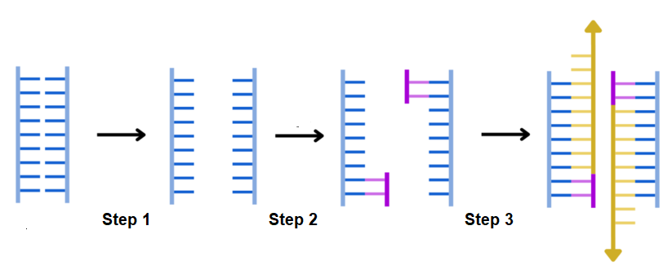

- State the full name given to this process. (1 mark)
_____________________________________________________________________

- Describe how the DNA strands are separated in step 1. (2 marks)
______________________________________________________________________
______________________________________________________________________

- Identify in which step of the process the following molecules would be utilised and describe their roles in this process.

- Primers (3 marks)
______________________________________________________________________
______________________________________________________________________
______________________________________________________________________
______________________________________________________________________

- Taq polymerase (3 marks)
______________________________________________________________________
______________________________________________________________________
______________________________________________________________________
______________________________________________________________________
Once copies of DNA have been produced, they need to be visualised either to create a profile or to be used in gene sequencing.

- Describe how gel electrophoresis is set up and what factors contribute to the banding pattern formed.
(7 marks)
______________________________________________________________________
______________________________________________________________________
______________________________________________________________________
______________________________________________________________________
______________________________________________________________________
______________________________________________________________________
______________________________________________________________________
______________________________________________________________________
______________________________________________________________________
______________________________________________________________________
______________________________________________________________________
______________________________________________________________________

The following diagram shows a phylogenetic tree of bears.

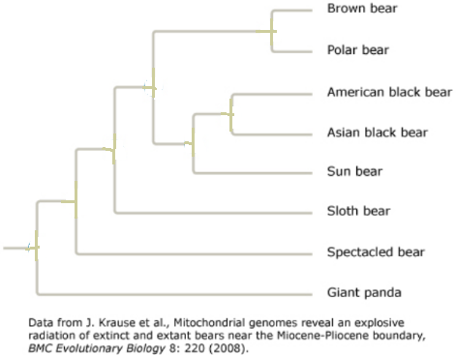

- Identify on the diagram above the following components of a phylogenetic tree.
(3 marks)

- use a labelled arrow to indicate an example of a node.
- use a circle to indicate an example of a clade.
- use a labelled arrow to indicate the root.

- Describe what this phylogenetic tree tells us about the evolutionary relatedness of the Brown bear to the American black bear and the Sloth bear. (2 marks)

______________________________________________________________________
______________________________________________________________________
______________________________________________________________________
______________________________________________________________________
______________________________________________________________________
______________________________________________________________________

Question 35 (19 marks)

  - Define the term homeostasis. (2 marks)
______________________________________________________________________
______________________________________________________________________

Homeostasis is mostly maintained by a process called negative feedback. Often this is represented by a negative feedback model.

(b) In the space below draw a labelled diagram that outlines the components that make up a negative feedback model. (5 marks)

Osmoregulation is an important process in both plants and animals.

A cross section of a xerophyte leaf is shown below.
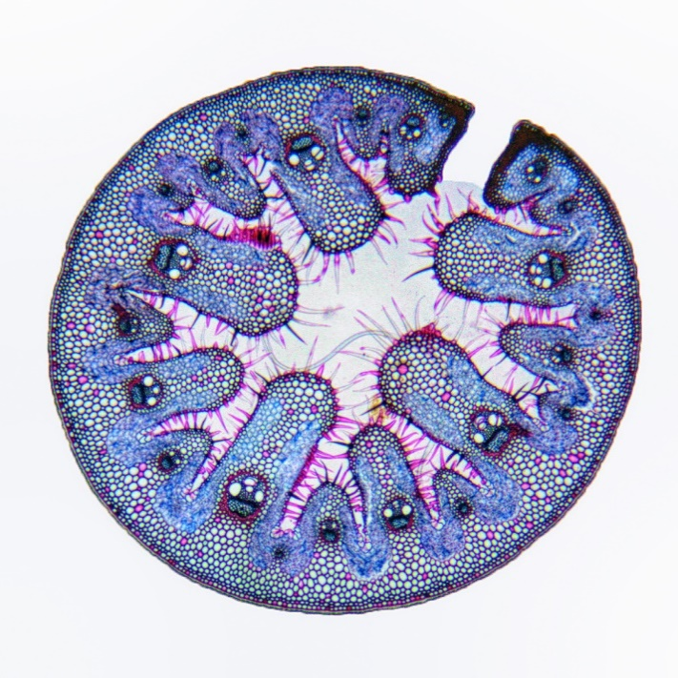

(c) State the type of environment in which you would find xerophytes. (1 mark)

______________________________________________________________________

(d) Identify two adaptations shown in the diagram above and describe the role of the adaptation in maintaining water balance. (4 marks)

Adaptation | Role in maintaining water balance

Halophytes such as mangroves must deal with osmotic stress associated with high salt
concentrations. They are often salt accumulators or salt excluders.

(e) Describe two mechanisms halophytes use as salt accumulators. (4 marks)
______________________________________________________________________
______________________________________________________________________
______________________________________________________________________
______________________________________________________________________
______________________________________________________________________
______________________________________________________________________
______________________________________________________________________

(f) Animals living in arid environments have evolved several adaptations in kidney nephrons that help to conserve water.
Describe two key adaptations in the nephron that conserve water.
______________________________________________________________________
______________________________________________________________________
______________________________________________________________________
______________________________________________________________________
______________________________________________________________________
______________________________________________________________________
______________________________________________________________________

End of Section Two
Section Three: Extended answer 20% (40 Marks)
Section Three consists of four questions.

Questions 36 and 37 are from Unit 3. Questions 38 and 39 are from Unit 4. Answer one question from Unit 3 and one question from Unit 4.

Use black or blue pen for this section. Do not use erasable or gel pens. Only graphs and diagrams may be drawn in pencil. Responses can include labelled diagrams with explanatory notes; lists of points with linking sentences; labelled tables and/or graphs; and/or annotated flow diagrams with introductory notes.

Supplementary pages for planning/continuing your answers to questions are provided at the end of this Question/Answer booklet. If you use these pages to continue an answer, indicate at the original answer where the answer is continued, i.e. give the page number.

Suggested working time: 50 minutes.
_________________________________________________________________________Unit 3
Choose either Question 36 or Question 37.
Indicate the question you will answer by ticking the box next to the question. Write your answer on pages 27 to 31. When you have answered your first question, turn to page 32 and indicate on that page the second question you will answer.
_________________________________________________________________________

Question 36 (20 marks)

The fruit fly, Drosophila, has many different species. Two of these species, Drosophila pseudoobscura, and D. mojavenisis, are thought to be closely related. The area where D. pseudoobscura is found is separated from the area where D. mojavenisis is found by a high range of mountains.

(a) Describe the process that has led to the creation of these two fruit fly species.
(10 marks)

(b) Describe how the processes of DNA replication and transcription are different.
(10 marks)

OR

Question 37 (20 marks)

(a) Describe the impact natural selection and genetic drift can have on allele frequencies within gene pools. (10 marks)

(b) Describe the role that fossils play in the creation of the geological time scale.
(10 marks)

Question number: ________________
___________________________________________________________________________
___________________________________________________________________________
___________________________________________________________________________
___________________________________________________________________________
___________________________________________________________________________
___________________________________________________________________________
___________________________________________________________________________
___________________________________________________________________________
___________________________________________________________________________
___________________________________________________________________________
___________________________________________________________________________
___________________________________________________________________________
___________________________________________________________________________
___________________________________________________________________________
___________________________________________________________________________
___________________________________________________________________________
___________________________________________________________________________
___________________________________________________________________________
___________________________________________________________________________
___________________________________________________________________________
___________________________________________________________________________
___________________________________________________________________________
___________________________________________________________________________
___________________________________________________________________________
___________________________________________________________________________
___________________________________________________________________________
___________________________________________________________________________
___________________________________________________________________________
___________________________________________________________________________
___________________________________________________________________________
___________________________________________________________________________
___________________________________________________________________________
___________________________________________________________________________
___________________________________________________________________________
___________________________________________________________________________
___________________________________________________________________________
___________________________________________________________________________
___________________________________________________________________________
___________________________________________________________________________
___________________________________________________________________________
___________________________________________________________________________
___________________________________________________________________________
___________________________________________________________________________
___________________________________________________________________________
___________________________________________________________________________
___________________________________________________________________________
___________________________________________________________________________
___________________________________________________________________________
___________________________________________________________________________
___________________________________________________________________________
___________________________________________________________________________
___________________________________________________________________________
___________________________________________________________________________
___________________________________________________________________________
___________________________________________________________________________
___________________________________________________________________________
___________________________________________________________________________
___________________________________________________________________________
___________________________________________________________________________
___________________________________________________________________________
___________________________________________________________________________
___________________________________________________________________________
___________________________________________________________________________
___________________________________________________________________________
___________________________________________________________________________
___________________________________________________________________________
___________________________________________________________________________
___________________________________________________________________________
___________________________________________________________________________
___________________________________________________________________________
___________________________________________________________________________
___________________________________________________________________________
___________________________________________________________________________
___________________________________________________________________________
___________________________________________________________________________
___________________________________________________________________________
___________________________________________________________________________
___________________________________________________________________________
___________________________________________________________________________
___________________________________________________________________________
___________________________________________________________________________
___________________________________________________________________________
___________________________________________________________________________
___________________________________________________________________________
___________________________________________________________________________
___________________________________________________________________________
___________________________________________________________________________
___________________________________________________________________________
___________________________________________________________________________
___________________________________________________________________________
___________________________________________________________________________
___________________________________________________________________________
___________________________________________________________________________
___________________________________________________________________________
___________________________________________________________________________
___________________________________________________________________________
___________________________________________________________________________
___________________________________________________________________________
___________________________________________________________________________
___________________________________________________________________________
___________________________________________________________________________
___________________________________________________________________________
___________________________________________________________________________
___________________________________________________________________________
___________________________________________________________________________
___________________________________________________________________________
___________________________________________________________________________
___________________________________________________________________________
___________________________________________________________________________
___________________________________________________________________________
___________________________________________________________________________
___________________________________________________________________________
___________________________________________________________________________
___________________________________________________________________________
___________________________________________________________________________
___________________________________________________________________________
___________________________________________________________________________
___________________________________________________________________________
___________________________________________________________________________
___________________________________________________________________________
___________________________________________________________________________
___________________________________________________________________________
___________________________________________________________________________
__________________________________________________________________________
Unit 4
Choose either Question 38 or Question 39.
Indicate the question you will answer by ticking the box next to the question. Write your answer on the pages provided.
__________________________________________________________________________
Question 38 (20 marks)

Small mammals such as the Desert Hopping Mouse can be found in central Australia where often fluctuations in temperature can be from -10°C to above 50°C.

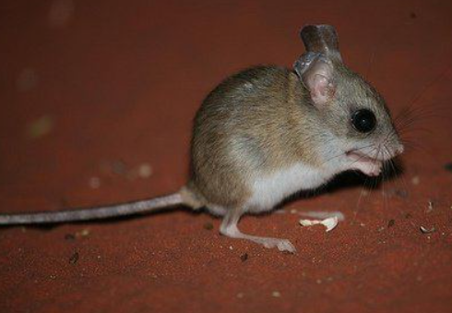

(a) The Desert Hopping Mouse is an endotherm.
Describe what this term means and explain how the mouse can survive in such a range of temperatures. (10 marks)

(b) Compare Phytophthora and Chytridiomycosis disease in terms of disease transmission, and management strategies. (10 marks)

OR

Question 39 (20 marks)

Lungfish are a group of fish that can breathe air using lungs and use gills to extract oxygen in water. The South American lungfish in particular lives in swamps and marshes where it is subjected to periods of time where the habitat dries up. These fish aestivate in mucus lined burrows. During the time it is burrowing it excretes urea and uric acid whilst when in water it excretes ammonia.

(a) Describe the significance to the lungfish of being able to excrete byproducts of deamination in the forms that it does. (10 marks)

(b) Describe the life cycle of the pathogen that causes influenza and explain the role that management strategies play in minimising spread of this disease. (10 marks)

End of questions
Question number: ________________
___________________________________________________________________________
___________________________________________________________________________
___________________________________________________________________________
___________________________________________________________________________
___________________________________________________________________________
___________________________________________________________________________
___________________________________________________________________________
___________________________________________________________________________
___________________________________________________________________________
___________________________________________________________________________
___________________________________________________________________________
___________________________________________________________________________
___________________________________________________________________________
___________________________________________________________________________
___________________________________________________________________________
___________________________________________________________________________
___________________________________________________________________________
___________________________________________________________________________
___________________________________________________________________________
___________________________________________________________________________
___________________________________________________________________________
___________________________________________________________________________
___________________________________________________________________________
___________________________________________________________________________
___________________________________________________________________________
___________________________________________________________________________
___________________________________________________________________________
___________________________________________________________________________
___________________________________________________________________________
___________________________________________________________________________
___________________________________________________________________________
___________________________________________________________________________
___________________________________________________________________________
___________________________________________________________________________
___________________________________________________________________________
___________________________________________________________________________
___________________________________________________________________________
___________________________________________________________________________
___________________________________________________________________________
___________________________________________________________________________
___________________________________________________________________________
___________________________________________________________________________
___________________________________________________________________________
___________________________________________________________________________
___________________________________________________________________________
___________________________________________________________________________
___________________________________________________________________________
___________________________________________________________________________
___________________________________________________________________________
___________________________________________________________________________
___________________________________________________________________________
___________________________________________________________________________
___________________________________________________________________________
___________________________________________________________________________
___________________________________________________________________________
___________________________________________________________________________
___________________________________________________________________________
___________________________________________________________________________
___________________________________________________________________________
___________________________________________________________________________
___________________________________________________________________________
___________________________________________________________________________
___________________________________________________________________________
___________________________________________________________________________
___________________________________________________________________________
___________________________________________________________________________
___________________________________________________________________________
___________________________________________________________________________
___________________________________________________________________________
___________________________________________________________________________
___________________________________________________________________________
___________________________________________________________________________
___________________________________________________________________________
___________________________________________________________________________
___________________________________________________________________________
___________________________________________________________________________
___________________________________________________________________________
___________________________________________________________________________
___________________________________________________________________________
___________________________________________________________________________
___________________________________________________________________________
___________________________________________________________________________
___________________________________________________________________________
___________________________________________________________________________
___________________________________________________________________________
___________________________________________________________________________
___________________________________________________________________________
___________________________________________________________________________
___________________________________________________________________________
___________________________________________________________________________
___________________________________________________________________________
___________________________________________________________________________
___________________________________________________________________________
___________________________________________________________________________
___________________________________________________________________________
___________________________________________________________________________
___________________________________________________________________________
___________________________________________________________________________
___________________________________________________________________________
___________________________________________________________________________
___________________________________________________________________________
___________________________________________________________________________
___________________________________________________________________________
___________________________________________________________________________
___________________________________________________________________________
___________________________________________________________________________
___________________________________________________________________________
___________________________________________________________________________
___________________________________________________________________________
___________________________________________________________________________
___________________________________________________________________________
___________________________________________________________________________
___________________________________________________________________________
___________________________________________________________________________
___________________________________________________________________________
___________________________________________________________________________
___________________________________________________________________________
___________________________________________________________________________
___________________________________________________________________________
___________________________________________________________________________
___________________________________________________________________________
___________________________________________________________________________
___________________________________________________________________________
___________________________________________________________________________
Supplementary page
Question number: ________________

___________________________________________________________________________
___________________________________________________________________________
___________________________________________________________________________
___________________________________________________________________________
___________________________________________________________________________
___________________________________________________________________________
___________________________________________________________________________
___________________________________________________________________________
___________________________________________________________________________
___________________________________________________________________________
___________________________________________________________________________
___________________________________________________________________________
___________________________________________________________________________
___________________________________________________________________________
___________________________________________________________________________
___________________________________________________________________________
___________________________________________________________________________
___________________________________________________________________________
___________________________________________________________________________
___________________________________________________________________________
___________________________________________________________________________
___________________________________________________________________________

Supplementary page
Question number: ________________
___________________________________________________________________________
___________________________________________________________________________
___________________________________________________________________________
___________________________________________________________________________
___________________________________________________________________________
___________________________________________________________________________
___________________________________________________________________________
___________________________________________________________________________
___________________________________________________________________________
___________________________________________________________________________
___________________________________________________________________________
___________________________________________________________________________
___________________________________________________________________________
___________________________________________________________________________
___________________________________________________________________________
___________________________________________________________________________
___________________________________________________________________________
___________________________________________________________________________
___________________________________________________________________________
___________________________________________________________________________
___________________________________________________________________________
___________________________________________________________________________
___________________________________________________________________________
___________________________________________________________________________
Spare grid




Acknowledgements

Question 28 | Birds and Their Internal Temperature Regulation – Nature Blog Network (hummingbirdsplus.org)
Question 30 | Geologic Time Scale | U.S. Geological Survey (usgs.gov)
Question 31 | Authors own pedigree
Question 34(a) | Download Scientific Diagram (researchgate.net)
Question 34(e) | Phylogeny Review Worksheet 2017.pdf (nausetschools.org)
Question 35 | https://d3jf2jipiivcgq.cloudfront.net/2430f19624252ca9901ceb22d5d033e809862e77.jpg
Question 38 | Spinifex Hopping Mouse (Notomys alexis), Central Australia… | Flickr

